CENTRAL FLORIDA LEADERSHIP ACADEMY, INC.

GRIEVANCE AND SPECIAL MAGISTRATE POLICY

POLICY OBJECTIVE: It is the policy of the Central Florida Leadership Academy to provide a clear, efficient and effective means of resolving issues that arise in the course of operation of the school, including issues that arise involving students, issues involving parents or guardians, and employee issues and grievances.

I. Initial communication on issues.
For issues with teachers, administration or staff, the initial communication regarding the matter should be with the party or parties involved.
II. Resolution by Principal.
If the issue involves a disagreement between staff members or between a student, parent or guardian with a CFLA staff member or CFLA policy, the affected individual(s) should make an appointment to discuss the matter with the school Principal. The Principal will respond within seven days from receipt of the complaint.
III. Resolution by the CFLA Board of Directors.
Issues that cannot be resolved by the Principal, may be referred to the CFLA Board of Directors for resolution. The attached form shall be used to request that the item be placed on the Board agenda. The Board will respond within 30 days of receipt of the complaint.
IV. Relief from the School District
If the issue is not resolved, the complaint may be sent to the OCPS following the procedures adopted by the District for complaint resolution.
V. Special Magistrate Procedure
For parental grievances involving a student’s health, safety or welfare under 1001.42(8)(c)1-7, Florida Statutes, unresolved grievances may proceed through the Special Magistrate process as set out in section 6A-6.0791, Florida Administrative Code.

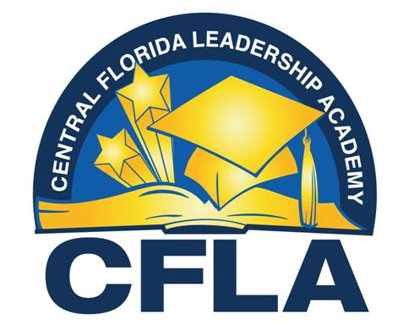

Board Meeting Appearance Request

Students, Parents, Teachers, Staff Members or others who wish to address the CFLA Board on matters that fall within the Board’s responsibilities (for example, appeals of faculty or staff terminations, review of the Principal’s recommendation for expulsion, annual budget, implementation and amendment of school policies) should complete the following form and submit it to the school office 48 hours in advance of any Board Meeting. Subjects involving school administration must first have been addressed with the Principal. Persons wishing to address the Board should limit any verbal presentation to five (5) minutes and should attach any documents they wish the Board to consider to this appearance request.

Name:__________________________________________________________________

School Affiliation if any (student/parent/faculty/staff/none):_____________________

Date of Board Meeting:___________________________________________________

Topic to be addressed:____________________________________________________

Brief summary of anticipated presentation:____________________________________________________________________________________________________________________________________________________________________________________________________________________________________________________________________________________________________________________________________________________________________________________________________________________________________________________________________________________________________________

Specific Board action requested:____________________________________________

