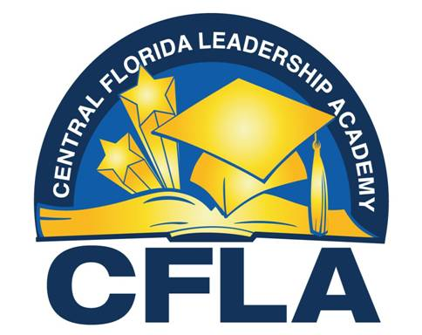

I am proud to share that Central Florida Leadership Academy has officially earned a "C", as previously projected. While we recognize that there is still significant work ahead, this achievement represents the dedication and commitment of our teachers, students, and school community. We were only 7 points away from earning a "B", and we are determined to continue building on this momentum.
One of our greatest successes this year was the growth demonstrated through student learning gains in both ELA and mathematics. Although many of our students have not yet reached overall achievement expectations, the data clearly shows that we are closing learning gaps and moving students forward.
Our strongest areas of growth, in which we outpaced the District and nearby schools included:
- 77% learning gains in mathematics among our lowest 25th percentile students
- 67% learning gains in ELA among our lowest 25th percentile students
These results demonstrate that the intentional changes we implemented, including stronger common planning practices, targeted interventions, data-driven instruction, and increased collaboration among teachers, are making an impact. Our students are growing, and our instructional systems are leading our school to positive results.

Maria Cameron, Principal

