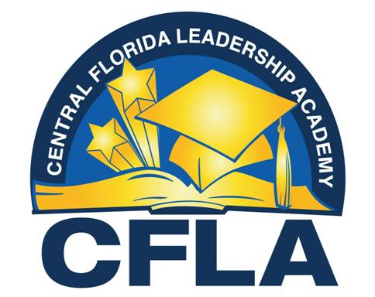

RE: School Grade/Performance

Although CFLA students demonstrated overall academic achievement growth for the third straight year in a row, for the 2024-2025 school year, CFLA received a school grade of “C”.

Full results can be found at FLDOE Accountability and Reporting:

https://www.fldoe.org/accountability/accountability-reporting/school-grades/